React Design Patterns

Design Patterns:

- [Instructor] So in this course, we're going to be learning quite a few different React design patterns, but before we get into that, I want to talk a little bit about what design patterns are in the first place. So the definition that I've come up with for design patterns is that. And notice here that I have effective underlined, because there are a lot of solutions to different problems that are not effective and that lead to more brittle code down the line and make your apps less performant and less maintainable. Those are generally referred to as anti-patterns. So design patterns are the positive equivalent of those, right? So in other words, they're the most effective solutions to a given development challenge. We'll see what I mean later on in the course. Now, one caveat before we move on is that many of you may have heard of design patterns used in a different context, such as object oriented programming. Well, the design patterns that we're going to be talking about in this course are not those. In other words, they're not the so-called Gang of Four object oriented programming design patterns, such as creational, behavioral patterns, et cetera. There's something a little bit different. Basically the patterns that we're going to be covering here are things that I've personally run into time and time again in basically every React application I've worked on. Some of these challenges include things like creating reusable layouts to put our components into, right? We'll see later on how to make things like split screens and modals. Another challenge is how do we reuse complex logic between our components? In other words, if we have two or more components that need to do the same complex things such as load data from a server, how do we best represent that in our React apps so that we can share that code between those components instead of having to copy and paste it. Another extremely common challenge is working with forms in React. This is something that despite hundreds of articles out there on how to do this correctly, I still see done incorrectly quite frequently. So we'll be discussing how to do that in React. And finally, we're going to see how to incorporate some concepts from functional programming into our React apps. This is something that I've been asked about quite frequently since my functional programming courses. And I'm very excited to share it with you in this course. Well, those are some of the common challenges we're going to be taking a look at. So let's jump right into the first pattern.

## Layout Components

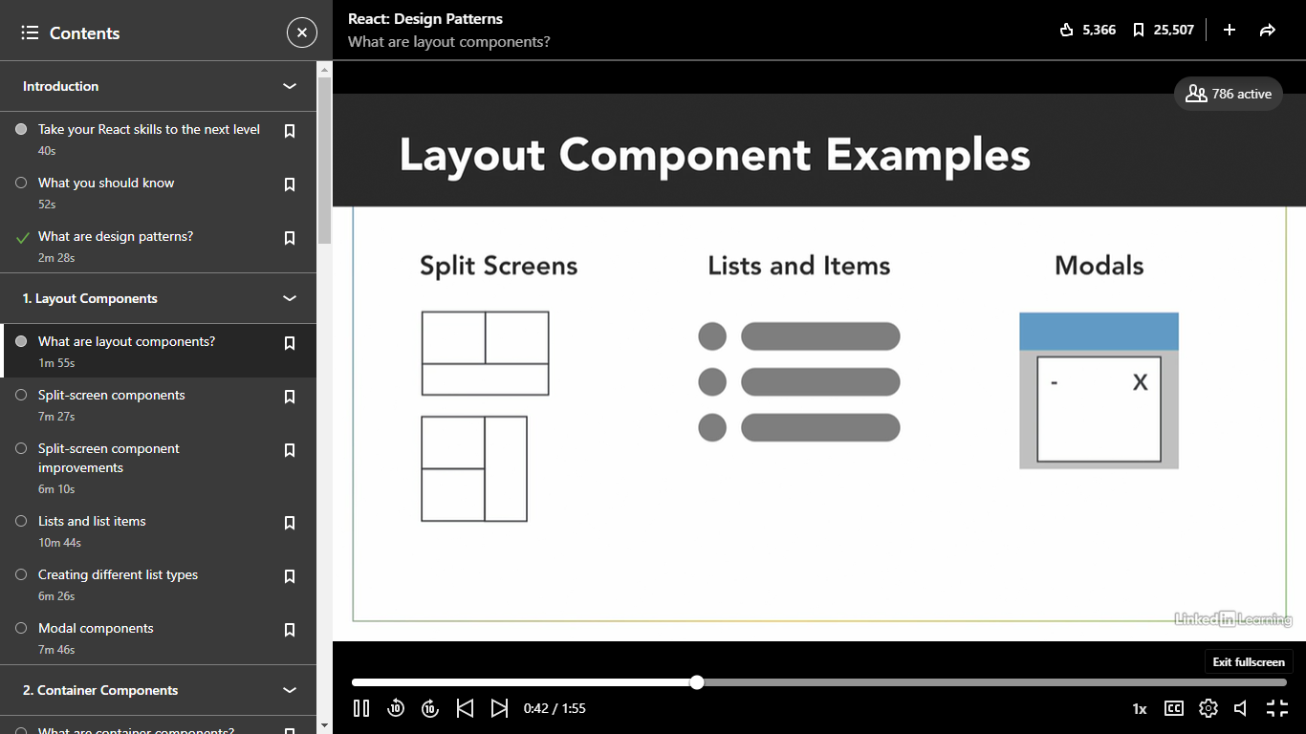

### **What are layout components?**

Selecting transcript lines in this section will navigate to timestamp in the video

- [Instructor] All right, so the first thing we're going to talk about are something called layout components. Let's start off with a definition here. Layout components are components in React whose primary concern is helping us to arrange other components that we create on the page. Some examples of this that you're probably familiar with, and that we're going to be taking a look at throughout the rest of this chapter are split screens, right, so arranging more than one component in different sections of the page. We also have lists and items, right? So displaying data in a list, this is a surprisingly hard thing to get completely right. And modals, which as most of you know, is just content that gets displayed over top of the actual page. So here's the basic idea of layout components and how we're going to go about creating them. Normally, when we create a component, let's say that we're creating a side navigation for our site, right? Just a bar on the left-hand side that contains some links. The normal way we would go about doing that, as you can see in this code on the left, is by actually including the div and the styles that go with that side nav inside the component itself. However, with layout components, what we do is we split the actual layout styles into their own component, and then simply display the component itself, in this case, the side nav, inside that layout component. And what this does is it separates the component itself from where the component's being displayed on the page, and it gives us a lot more flexibility for how we use it in the future. So with all that said, the main idea of layout components is that our components that we create, right, the main content components of our pages, shouldn't know or care where it is that they're actually being displayed on the page. So just keep that in mind that that is the main idea of layout components.

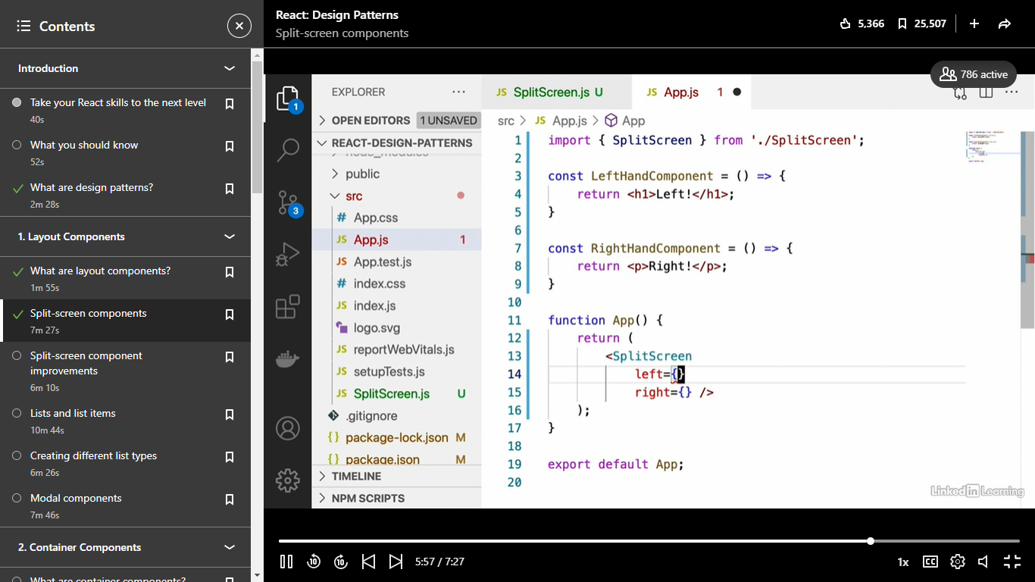

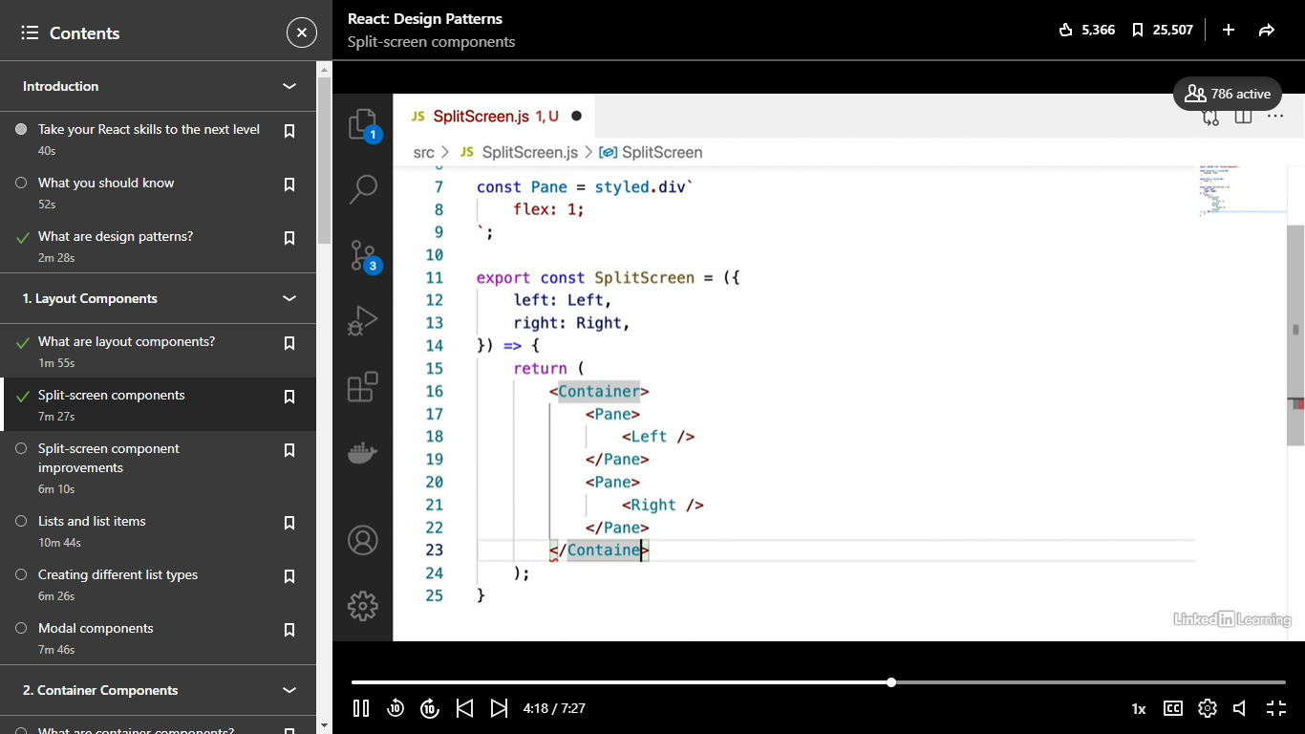



## 

- [Instructor] All right. So now that we've seen how to implement a basic split screen component, I'm going to show you a few modifications that we can make to that component in order to make it a little more developer friendly. So the first thing we're going to see is how to add weight to different components displayed by our split screen. What I mean by that is we might want our left component to take up less space and our right component to take up more space or vice versa. Now, the way that we can do that is simply by adding two more props to our split screen component. The first one is going to be left weight, and we're going to give that a default value of one. And we'll also have right weight, which will also give a default value of one. Oh, and the syntax for that is left weight equals one and right weight equals one. Okay, so basically all we have to do now is just pass this left weight and right weight through to their respective pane components and then modify this flex property accordingly. So what that's going to look like, and this is just how it works with styled components, we're going to say weight equals left weight. And for our right pane, we're going to say weight equals right weight. All right. And then we just have to go up to our pane component here, and we're going to insert the value of that weight prop into the flex property. And the way we're going to do that, again, this is just the way it works with style components, so don't worry about the syntax here, is we're going to say props and we're going to map that to props dot weight. Okay, so in other words, whatever we pass in for left weight and right weight, will replace this here. So if we pass in one, it'll be flex one. If we pass in five, it'll be flex five, et cetera. Okay, so let's see how to use this. We're going to open up our app dot JS component now and add these two other props that we just created. So we're going to say left weight, and let's say that we want the left-hand side to be one third as large as the right hand side. Well, since the weight props that we've defined pretty much reflect how Flexbox works. Our left weight is going to be one and our right weight will be three. All right, so our left weight is going to be one third as wide as our right weight here. Okay, so let's take a look at our app now. And we see that the left-hand side of our split screen is now a third as wide as the right-hand side. So this would be good if we wanted to display something like a side nav of some sort. So we've seen how to add weight to the different items in our split-screen component. And the next optimization that I'm going to show you is that instead of passing in our left-hand component and right-hand component as props, it's possible with layout components to make them accept their children as children in the sense of react. Let me show you what I mean by that. Instead of passing left and right as props, okay, we're going to keep our left weight and right weight here, instead of passing our left and right components as props, we're actually going to put them inside our split-screen component as children. What that's going to look like is this, we're going to say left-hand component and right-hand component like that. And then in order to make this work with our split screen, we're going to need to open that up. And we're going to remove the left and right props here and replace that with the children prop. And then what we're going to do is down here in the body of our split screen component, we're going to say const. And since children is going to be an array in this case, containing all of the elements that we passed as children to our split-screen component, what we can do is say const left and right. And notice we're not using capital letters in this case, since these are elements and not components, we're going to say equals children. And then instead of left as a component, we're going to display left, just using the curly braces. And then for right, we're going to do the same thing. Okay, so we have left and right inside curly braces. And as we can see now, if we go back over to our app, nothing has changed except that this is generally considered to be more developer friendly, right? Being able to pass in components as children to a layout component instead of having to pass them in as props. And what this also allows us to do is for our left-hand component, if our left-hand component needs to accept props, let's say that it needs a name prop of some kind and our right-hand component takes a prop. Let's say message. Okay. And let's display those inside of there. So we'll say message and name. Okay. If we want to pass those props into our left and right-hand components now, we can just do that directly. So we can say name equals Shaun, for example, and for our right-hand component, we can say message equals hello. Okay. And we can see that that works just like we want it to, whereas if we were rendering these components inside our split-screen component and passing them through as props like before, we would have to actually pass those name and message props through our split-screen component to our left and right components respectively. So we would have to add something like this and say, right props equals blah, blah, blah. That would be an object. And the same thing with left props. And we would have to pass those directly to here. So this is just a much easier way to do it right. Saying left and right. And that allows us to pass props directly to it. And it's just considered to be a little more readable that way.

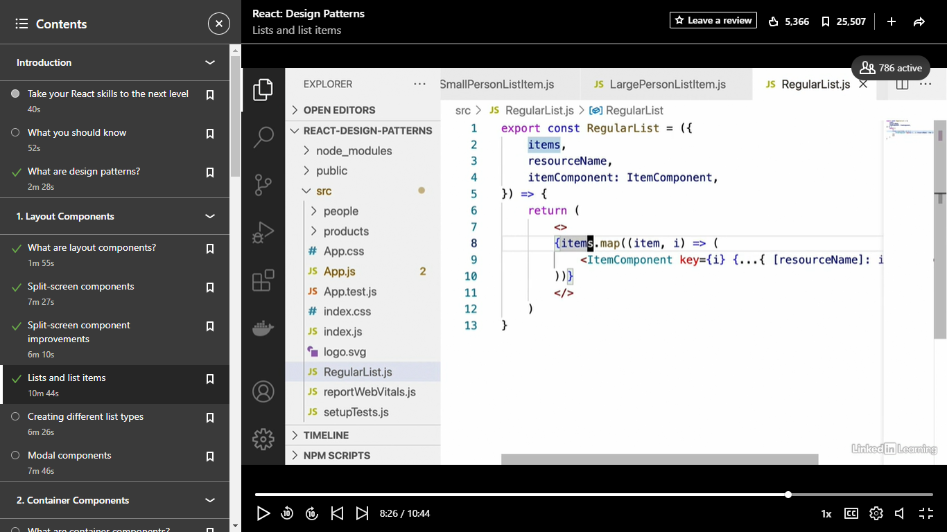

- [Instructor] All right, so the next design pattern that we're going to take a look at here with layout components is lists and list items. Now, to start off here in the exercise files, you're going to find something a little bit different. Inside the app component, we have an array of people data and an array of products data, and what we want to do is display this data inside several different kinds of lists. So I'm going to show you how to create some list and list item components that can help us do this most effectively. So, first of all, let's create a few different kinds of list items for the people and the product. We've got different data to display here, such as name, age, hair color in the people than we do with our products where we have name, price, description, et cetera. So let's start off by creating some list item components and we're actually going to create two different variations of list items for each type of resource. So let's create a folder for our people, and inside there, we're going to create a SmallPersonListItem.js and a LargePersonListItem.js. Okay, and we're going to do the same thing for our products. So let's create a product folder, we'll say products, and inside there, we're going to say SmallProductListItem.js and LargeProductListItem.js. All right, so let's go through real quick and implement each of these. First of all, we're going to start off with our small person list item, and we're not really going to add any styling to these. It's really just going to be small or large depending on the quantity of information that it displays. So for our small person list item, I'm just going to type this out real quick, we're going to say export, const, small person list item. It's going to take a person as a prop. It's going to get only the name and age from that person props, so we'll say const, name and age equals person. And then, what we're going to do is return a paragraph that says name, name, comma, age, and then we'll put in the person's age and we'll put years after that. So that's our small person list item. Now notice that this small person list item doesn't really contain any styling that would indicate it knows where it's being displayed. In other words, we could display the small person list item in a numbered list, in a very narrow list, in a very wide list, and we could use the styling in its parent component to determine how it gets displayed. We'll see that in more detail a little later on. For now, first, let's implement our large person list item. For that, I'm just going to copy and paste our small person list item into large person list item. We're going to have to change the name here and this one's going to display a little more information than the small person list item. What we're going to do is get the name, age, hair color, and hobbies, properties from the person, and we're going to display them like this. Now, we're going to display all of this inside a react fragment for the same reason that I mentioned before. We don't really want this large person list item to be determining its own styling, we want its parent component to be able to do that. So we're going to have the name displayed like this. We're just going to say name, inside an h3 tag. Under that, we're going to have a paragraph tag with the person's age, we'll say age, age years. Under that, we're going to have their hair color. So we say hair color and insert the hair color into the JSX there. And then under that, we're going to have an h3 heading that says hobbies, and we're going to display all of their hobbies here. Remember that hobbies is an array if you go back and look at the original data. So we're going to say hobbies, under that, we're going to put an unordered list and we're going to map the hobbies. So we're going to say hobbies.map and for each hobby, we're going to add a list item which we'll need a key, of course, that key is just going to be the hobby itself, and we'll insert the hobby string into that list item. So that's our large person list item and our small person list item. Now, before we go on to implementing the small product and large product list items, I want to actually create the list components themselves. So, currently, we've only been creating the actual list item components. So let's take a look at what the lists that are going to display these components are going to look like. Now, contrary to what you might be expecting where we might have a large person list and a small person list, and a large product list and a small product list, we're actually just going to have a single list component that can display all of these different list items. Let me show you how that works. Inside the source folder, we're going to create a new file and we'll call this regular list. I'll show you how to make other types of lists in a minute here. And here's what regular list is going to look like. We're going to say export, const, regular list, and this list is going to take the items that it should display. So it's taking a prop called items and it's also going to take a prop called resource name. So this is going to be either products, or people, or whatever kind of resource that this list is going to be displaying. You'll see how we use that in a second. Now, the final prop, and I'm going to just indent all of these for readability. The final prop here is going to be called item component. Now, this is going to be the actual component that we use to display each of the items in this items array prop that we're getting here. So just like we did with the left and right-hand components when we saw how to do a split screen, we're going to rename item component so that it's got a capital letter. This just keeps in with React's convention of capital letters at the beginning of their component names. And then for the body of the component, here's what it's going to look like. It's actually going to be very simple. We're just going to say return and inside some react fragments. We're going to map over all of the items and display one item component for each of them, passing it to the prop called resource name. That might sound a little confusing but here's what it looks like. We're going to say item.map. We're going to get the item and its index here. And then, we're going to display the item component and pass through the current item that we're looking at to the prop with the name of a resource name. And what that's going to look like, this might look a little confusing for you. First of all, we need to add a key, which is just going to be the index. Normally, you're not supposed to use index as keys but we're just going to do that for now. We're going to use the spread operator, so dot, dot, dot, and then we're going to spread an object with a key that's going to be that resource name prop that we had up above, and we're going to pass through item for that. So what this is going to change to, let's say that we pass in person as resource name, this is going to change to person equals item. So that's what that's going to change to. It's kind of a confusing syntax at first but it's something you'll get used to. So that is how our regular list component works. Oh and this should be items.map, not item.map. All right, so let's see how our regular list works now. Let's open up our App.js component and display two lists, one which is going to display all small person list items and one which is going to display all large person list items. All right, so down here in our app, we're going to remove this h1 tag that I put there. We're going to display our regular list, which my IDE is going to import for me automatically. And then for the props, we're going to say items equals people. Under that, we're going to say resource name equals person. Remember that this resource name is the name of the prop that our small person list item and large person list item are expecting. And finally, we're going to pass through the component that we want each of these people to be displayed inside of. So we're going to say item component equals and we're going to include one with our small person list item, which again is going to be imported automatically for me. So make sure you go up and do that if your IDE doesn't do that. And that's how the regular list works. So we have one regular list with our small person list item. Under that, let's display one with the large person list item, just to show you what's possible with that. We're going to say item component equals large person list item. And now, if we run our app, which you can again do with NPM run start, we're going to see that up here at the top, we have a list of our people with the small person list item component. And down below, we have the same list component displaying a completely different list. For all of the people, it's using the large person list item. And I just want to point out before we move on that the regular way of doing this is not to have this reusable list component. It's, instead, to create a large person list item list and a small person list item list that then display those components. So, as you can see, the way that we've done it here makes the regular list a lot more reusable. We're able to simply pass in the component that we want to be displayed as children of this list.

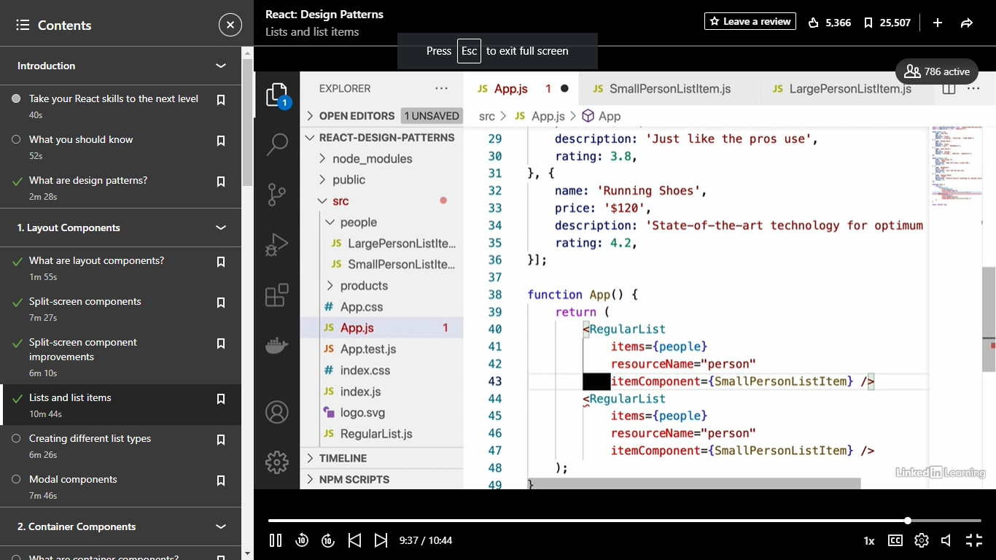

## Loading data from data storage

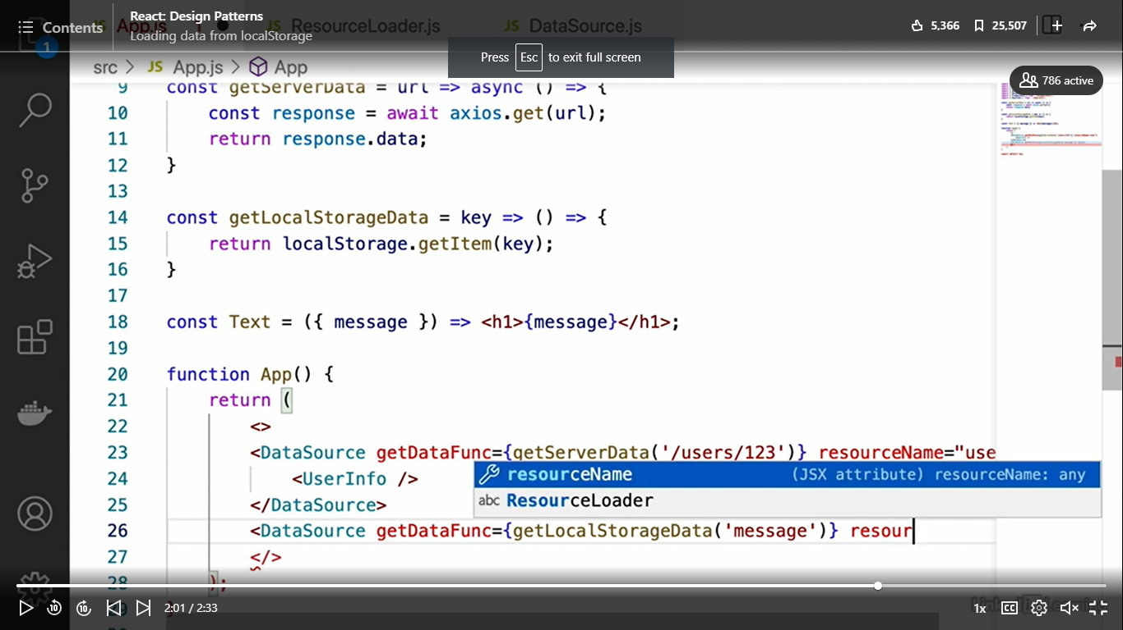

### 

Selecting transcript lines in this section will navigate to timestamp in the video

- [Instructor] Now that we've learned a little bit about what container components are exactly and their main goal, what we're going to do is take a look at a few examples that demonstrate how container components are used. The way we're going to go about this is we're going to start off with a fairly simple and not very re-usable example. Over the course of the next few videos, we're going to improve it and slowly make it more and more re-usable until we reach what I would consider a good stopping point. The first thing you're going to want to do here is get the starting state of the exercise files because it's different than the way we left it after we talked about layout components. Let's just discuss a few of the things that it contains. The first thing is this app component. There's not really anything in here. We've basically cleaned it all out of the code that we wrote before. Then we also have these UserInfo and ProductInfo components, which are basically just slightly-modified versions of the large person list item and large product list item components that we wrote previously. The main difference is that with our large person list item component, we've just changed the word person to user, because that's a more realistic scenario for most applications, is users. We have our UserInfo and ProductInfo components, which take a user and product prop separately. What we want to have these components do is display some data that we load from a server. That's the last file I wanted to talk about, is this server.js file that you'll find in the root directory of the exercise files. Basically, this is just a simple express server that will send back some data to our components. This is just to simulate a real-world, full-stack React app. We have the current user here. We have an array of all of the users on our site. There's only three of them as you can see, and we have an array of products. Then below that, we just have a few different endpoints that are going to send that data that we've looked at before back to our client side. We have a current user route for getting the information for the current user. We have a users ID route. Basically, this allows us to get an individual user by their ID. We have a post users ID, which allows us to modify users. We have a get all users endpoint, we have a get product by ID endpoint, and we have a get all products endpoint. Don't worry too much if you're not super familiar with backend development. You don't need to know all about express servers. I'll explain when we actually make requests to this server what each request is supposed to be doing. I'm going to close this server.js file since we won't be making any changes to it in this course. We're just going to use that as, basically, a mock that we're going to send requests to from our React application. But one thing you are going to want to do is know how to run that server. The way you're going to do that is by typing node and then the path to that file, which is just going to be server.js, provided that you're in the root directory. You should see that it says server is listening on port 8080. Just as a side note, you do need to run npm install in the exercise files directory before this will work.

### Container components

Take care of loading data for chilrens

- [Instructor] Okay, so the next React design pattern that we're going to take a look at is something called Container Components. So what are container components exactly? Well, container components are basically React components that take care of all of the data loading and other data management for their child components. In order to show you what I mean with this, let's imagine that we have the setup that you see here, a container component with several child components inside of it. Well, normally what you would do, if you're like most beginning to Intermediate React Developers is you would just have each of those child components load their own data and then display it, right? So up where it says low data, you probably have a useState hook and a useEffect hook and use something like Axios or Fetch to get data from a server. Now, the problem with this is that a lot of the time we need our child components to be able to share that logic. And the way that container components solve that problem is by splitting that logic out into its own component, which is the container and the container then takes care of loading that data and passes it automatically to the children components. We're going to see how exactly this works very soon. So then the main idea of container components is this, just like how with layout components, we didn't want our child components to know or care what layout they were part of. With container components, we don't want our components to know where their data is coming from or how to manage it. We just want our components to be dumb and take some props and display whatever they need to display.

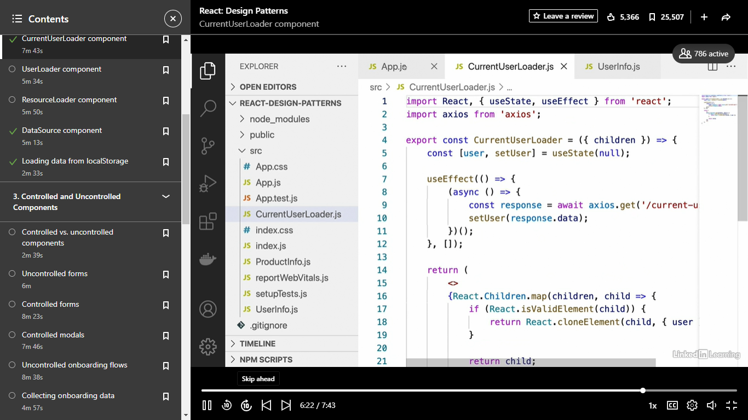

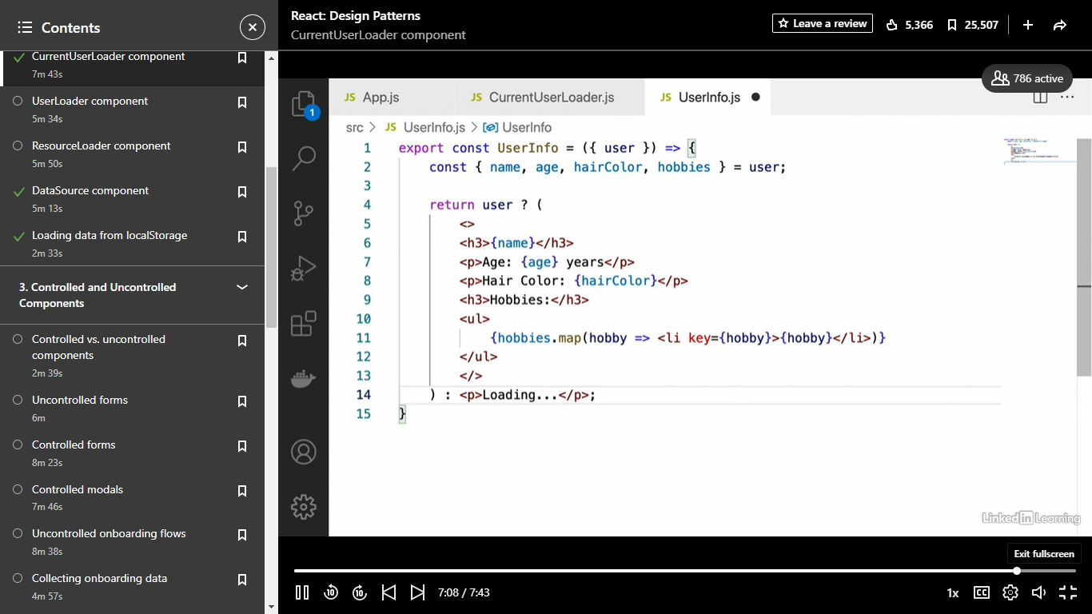

- [Instructor] All right, so now that we've implemented this CurrentUserLoader, it's time for me to point out a few things that aren't quite right about it, or aren't quite ideal, at any rate. The main thing that's not ideal about our CurrentUserLoader is that it's very restricted in what it's capable of doing. Essentially, all this CurrentUserLoader does is load a single user and passes it to its children, and that single user is this currentUser that we're loading from the server. So what we're going to do, in this video, is modify our CurrentUserLoader component so that instead of just loading the currentUser, it's able to load any user we want by their ID. In fact, what we're going to do instead of modifying the CurrentUserLoader, we're just going to create a new file which we'll call UserLoader.js. And we're going to start off by just copying and pasting all of the code over from CurrentUserLoader into UserLoader. And, of course, changing the name of the component to UserLoader instead of CurrentUserLoader. Okay, now the main thing that we're going to change, about this UserLoader, is the URL that it's going to send a request to, right. When I showed you the server, we saw that the currentUser endpoint sent back just the data for the currentUser. And, just to show you that, let me open up the server and we can see that this currentUser, here, is what gets sent back in our currentUser endpoint, right, we're just sending back that currentUser object. So what we're going to do instead is send a request to this users/:id route, which allows us to get any user by their ID. So here's what that's going to look like. We're going to replace the endpoint that we're sending a request, here, to. We're going to use back ticks because we want to insert a value into this string. And we're going to say /users/, and then we want to insert the ID of the user that we want to load. Now the main problem, here, in this UserLoader component, is that we don't know what user ID we want. So what we're going to do is have the parent component, that's probably going to be the app component in our case, pass in the user ID as a prop. So we're going to have userId be a prop, along with children, and we're just going to insert that into the URL here. All right, and now that we've done that, we need to put userId into the array of useEffect, so that useEffect will run whenever this changes, although, in reality, it shouldn't. And then we're, actually, going to open up our server.js file. I may have mentioned earlier that we wouldn't be changing it, but that's not entirely true. And what we're going to do is add IDs, to these three users in our array, in order for everything to work. So we're just going to add some very simple IDs. The first one should be 123, the second one should be 234, and the third one we'll make 345, okay. And you can add one to the currentUser as well, if you want, we'll just make that 123, just like the user in this array, here, with the same name. And we're probably going to want to do the same thing for products, so we'll say products, we'll make these IDs four digits. So we'll have 1234, id: 2345, id: 3456, and that should make everything work just like we want it to. Okay, so now that we have this UserLoader component, which provides us with a little bit more flexibility than our CurrentUserLoader component, let's see how we can use it inside app.js. Okay, so we're going to import our UserLoader from UserLoader and we're going to replace CurrentUserLoader with UserLoader, and we're going to pass the userId as a prop to it. So we're going to say UserLoader userId, just to check, let's do 234. Okay, and we're going to change this closing tag to UserLoader as well. And one last thing we need to do, before this will actually work, I realized I didn't do it before, is since we've made changes to our server, we need to actually restart it in order for those IDs to take effect. Okay, so now we should be good to go. Let's head over and check in the browser. And we should see that Brenda Smith is, indeed, loaded from the server, right, because they are user 234. So what we can, actually, do with this UserLoader is we can reuse it several times over, right. And, of course, we're going to need to wrap this in React fragments like this. But what we can do is say we want user 123, we want user 234, and we want user 345, and each of these respective container components will load only that user with that ID and pass that different data to the same component, which will give us all of our users rendered in a, sort of, list here. If we wanted to, we could even say something like const userIds equals 123, 234, 345, and then just map these IDs and have UserLoader pass that ID and have UserInfo inside of it. I'm not going to do that here, but that would be something that you could definitely do.

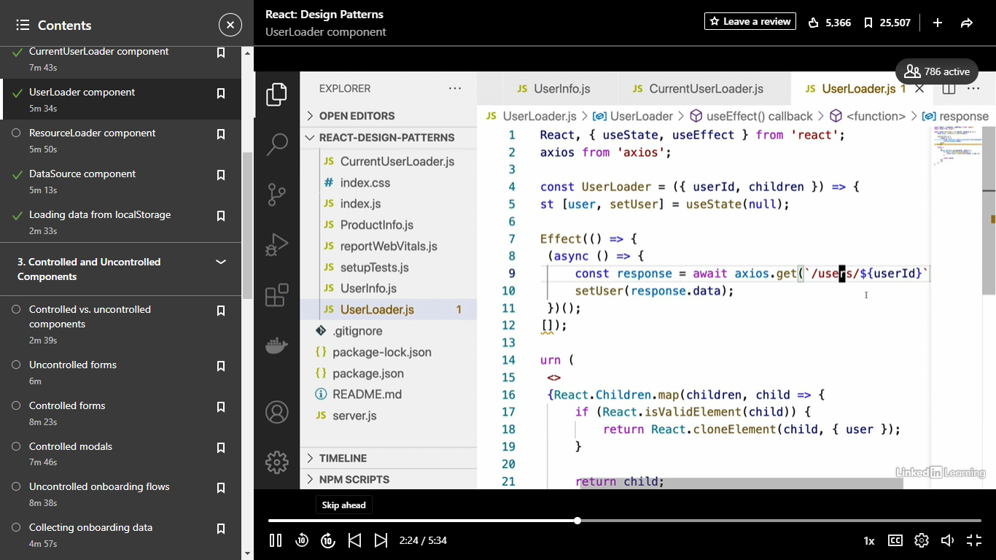

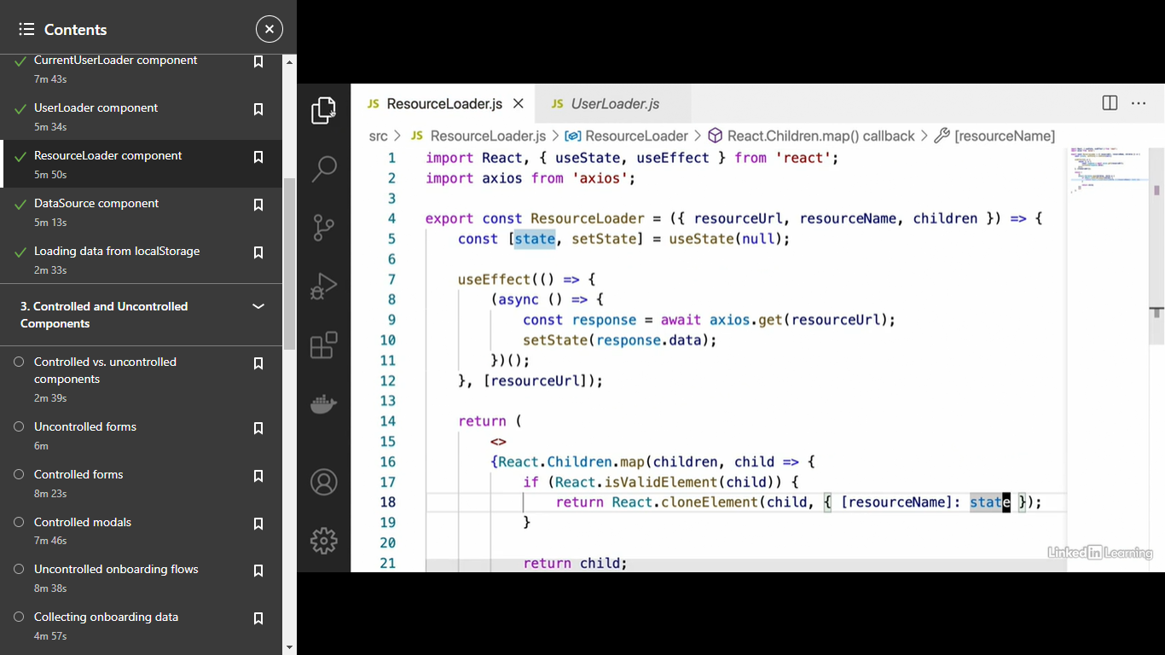

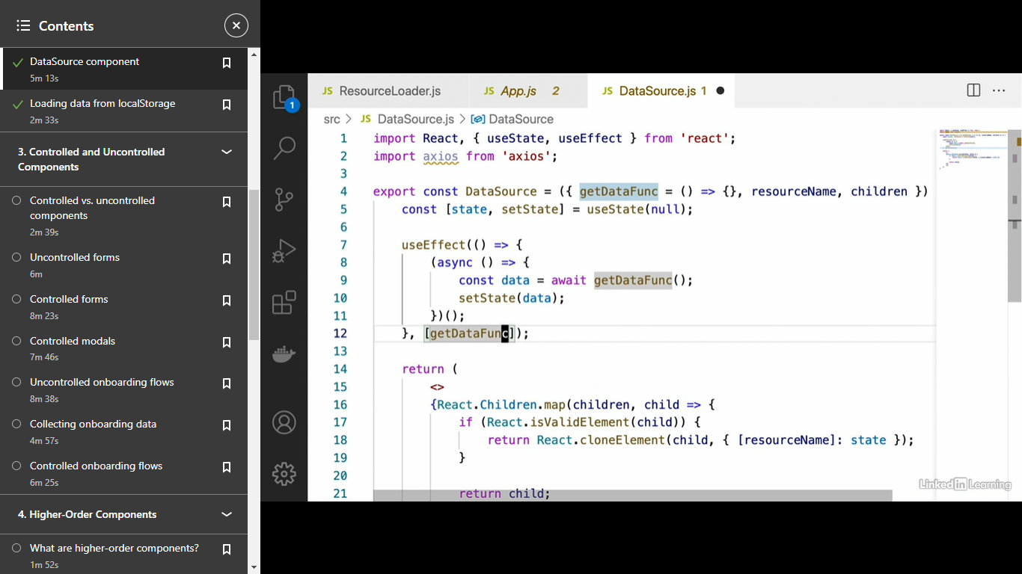

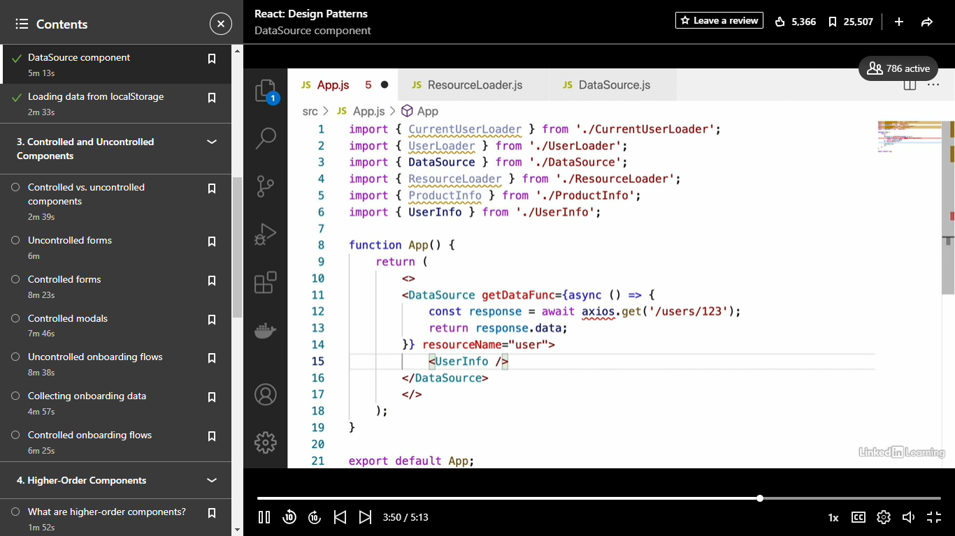

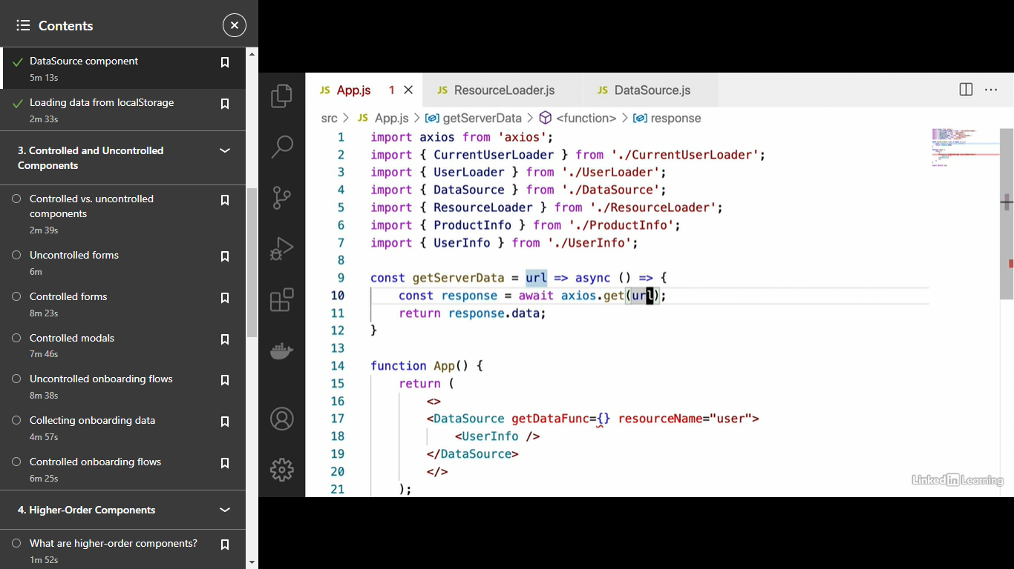

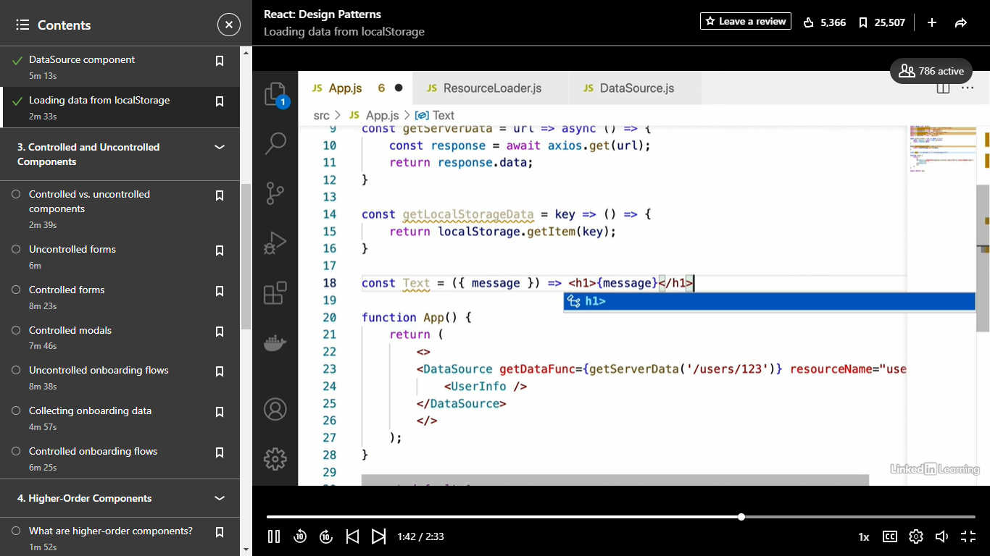

- [Instructor] All right, so the next React design pattern that we're going to take a look at is controlled and uncontrolled components. Now, this is a very, very common pattern to find in React, both of these, both controlled and uncontrolled components, so let's take a look at what both of these mean. First let's start off by defining uncontrolled components. Uncontrolled components are basically React components where the component itself keeps track of all its own internal state and really the only time we get data out of that component is when some event occurs. So this would be in the case of, let's say, a form when the user hits the Submit button. In an uncontrolled form, that would be the only time we actually know what values the inputs of that form contain. Controlled components, on the other hand, are basically components where their parent is the one that takes care of keeping track of the state and that state is then usually passed through to a controlled component as a prop of some sort. So those are just the basic definitions. Let's take a look at what this might look like in code. For uncontrolled components, more often than not, the component itself again is going to be the one that keeps track of its own state. So what this is going to look like up here at the top, we see that this component has its own useState hook and the only prop that it's getting past is this onSubmit prop, which the parent component would pass a function to to actually get the values of that component's state when the submit event is triggered. With controlled components, on the other hand, we see that our component no longer has that useState hook. In other words, the state of that component is passed through as props. And, of course, there's other kinds of functions that this component is going to use, as well. You'll see how this works very shortly when we take a look at some examples of this. So one question that comes up when we talk about uncontrolled and controlled components is which one do we generally prefer? Well, more often than not, we're going to prefer controlled components and there are several reasons for this. The main reason is that it just makes our components more reusable and it also makes them a lot easier to test since we can just set up a component with the exact state we want, instead of having to create the component manually, make some changes, and then trigger some event to find out what's going on inside of it. So in other words, controlled components are just easier to test, they're more reusable, we more often than not will prefer them.

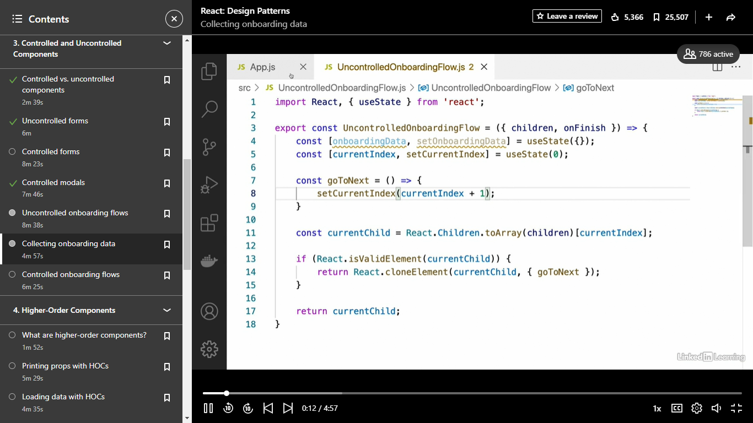

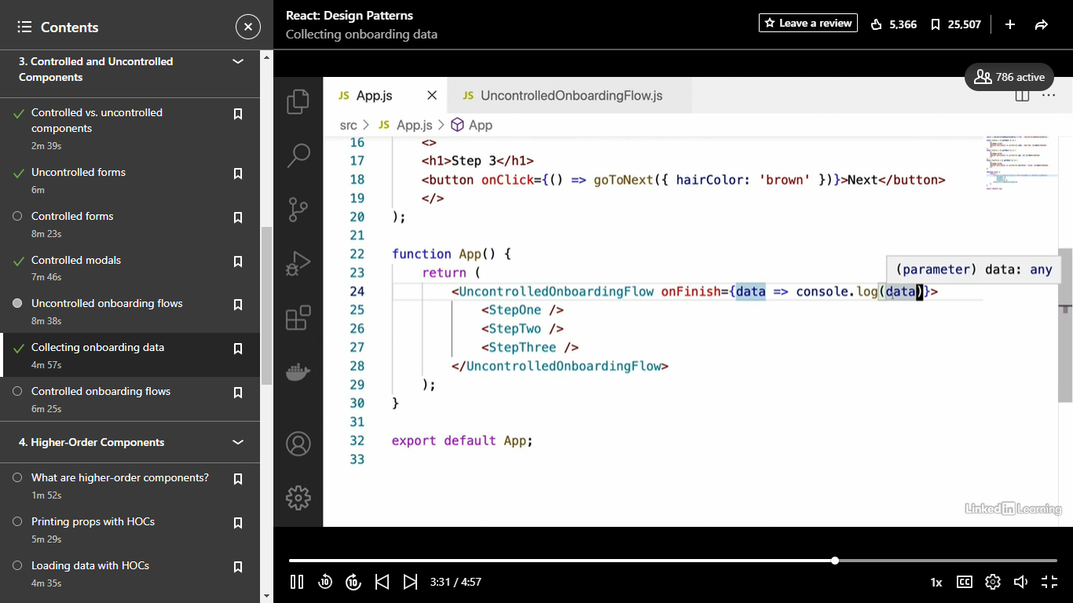

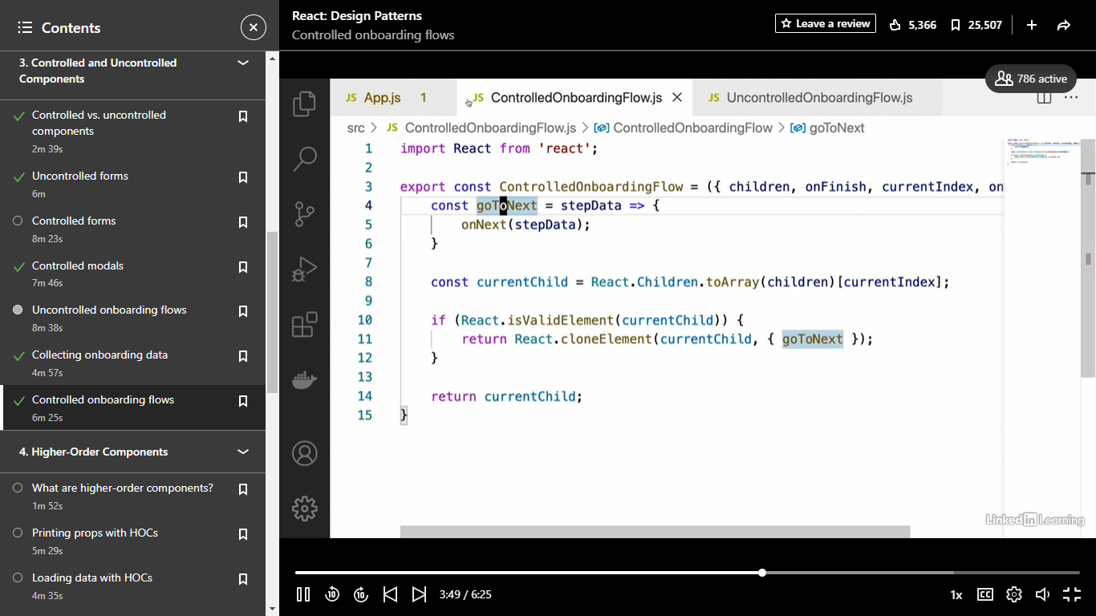

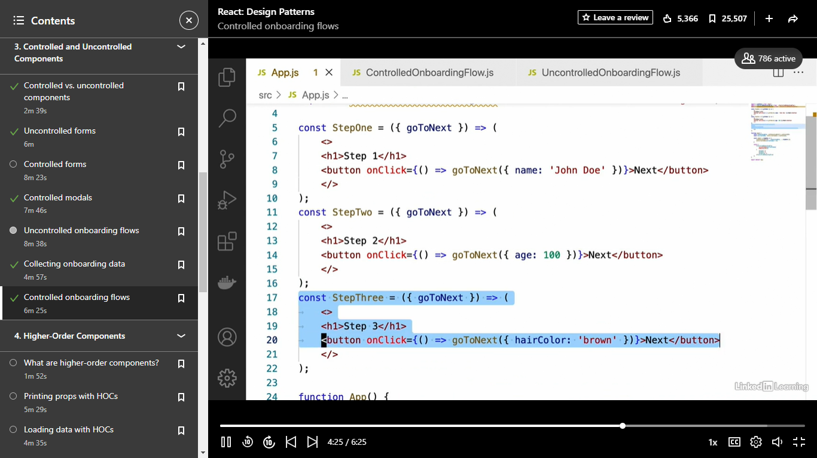

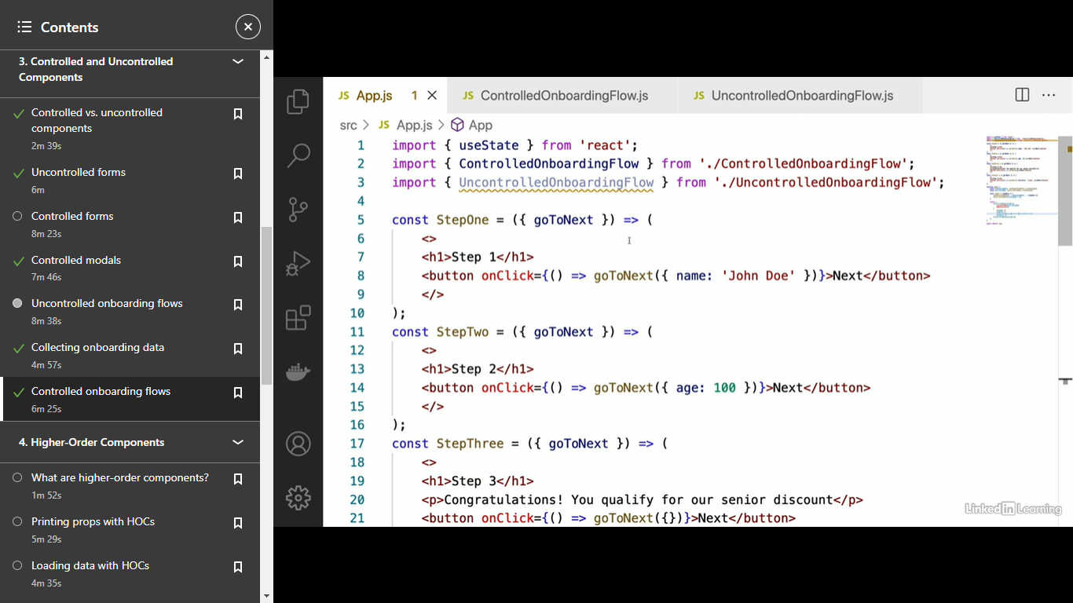

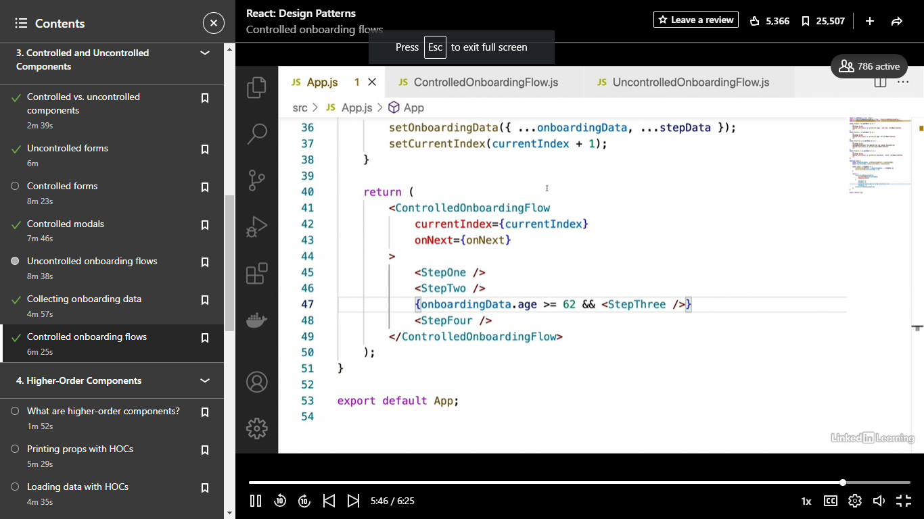

### Higher order functions

- [Instructor] All right, the next React design pattern that we're going to take a look at is something called higher-order components. Now, higher-order components are basically components that instead of just returning JSX, they return another component. That might sound like somewhat of a confusing topic at first, so let's take a look at the basics behind how it works. So as everyone should know, most components in React simply return some sort of JSX, which represents the DOM elements that that component wants to be rendered in its place. However, with higher-order components, as I said, they return a component which then returns JSX. So basically what we're doing here is adding an extra step inside of it. Now, if that still sounds confusing, just remember one thing for now before we take a look at our examples, and that is that higher-order components are just functions that return components. So if you want to think about them as sort of component factories, right, functions that you can call to create new components, if that works for you, then go ahead and think about it that way for now. So the next question is why would we want to actually create these higher-order components? Well, one thing that higher-order components are used for is sharing behavior between several of our components, right? And this is actually a lot like what we saw with our container components, how we were able to wrap different types of components in the same container and have them behave somewhat similarly. So higher-order components allow us to do something similar to that, as you'll see. Another thing that they're used for is to add extra functionality to an existing component of ours. So if we have an existing component that someone else built, what we can do is use higher-order components to add new functionality to that component.

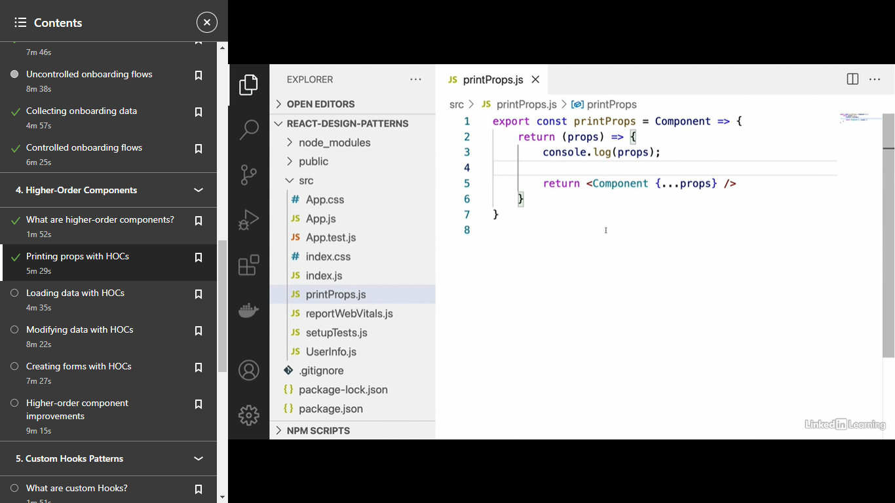

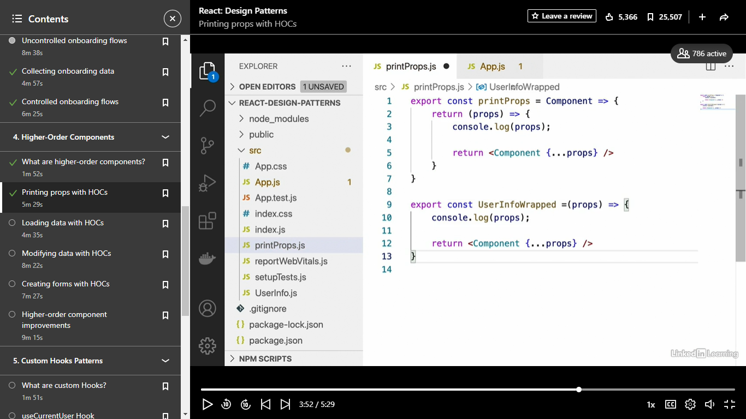

Loading data with HOC

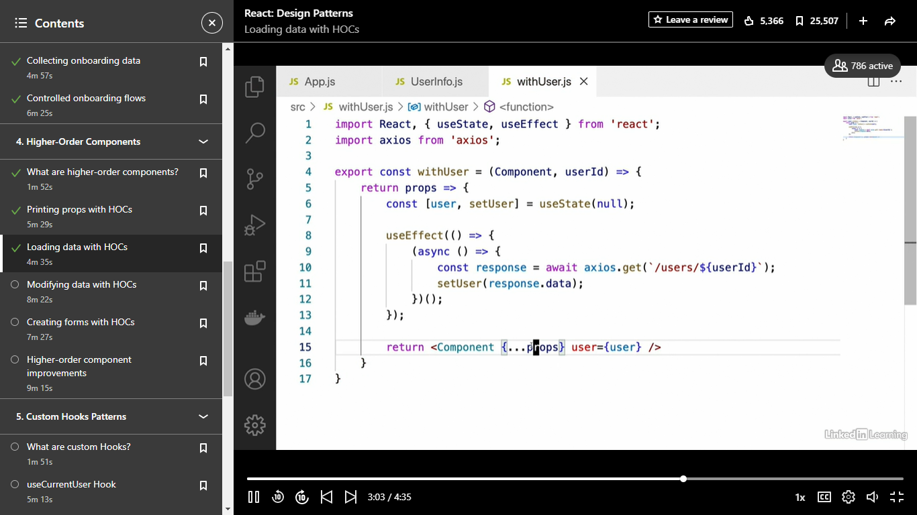

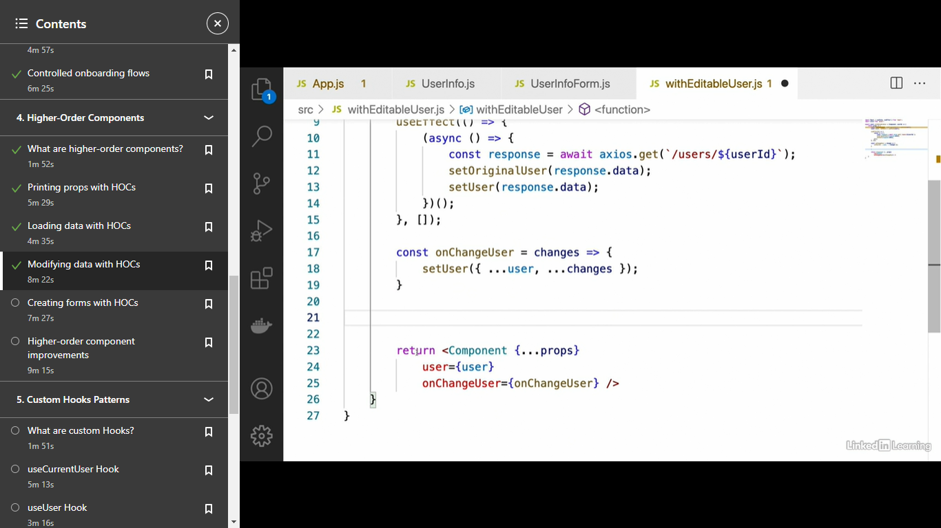

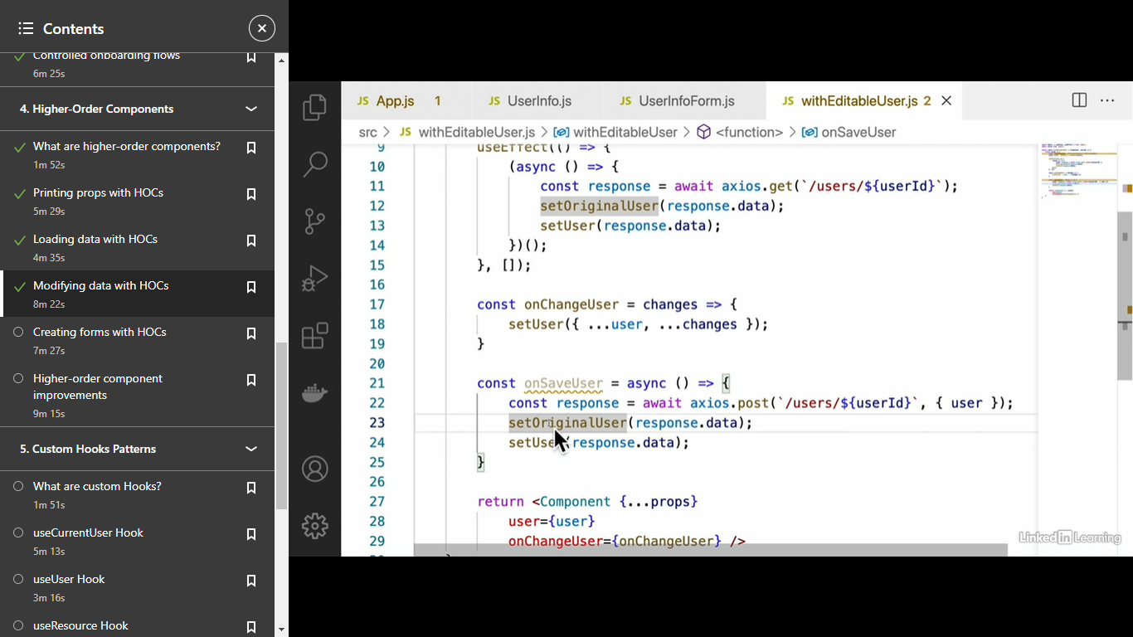

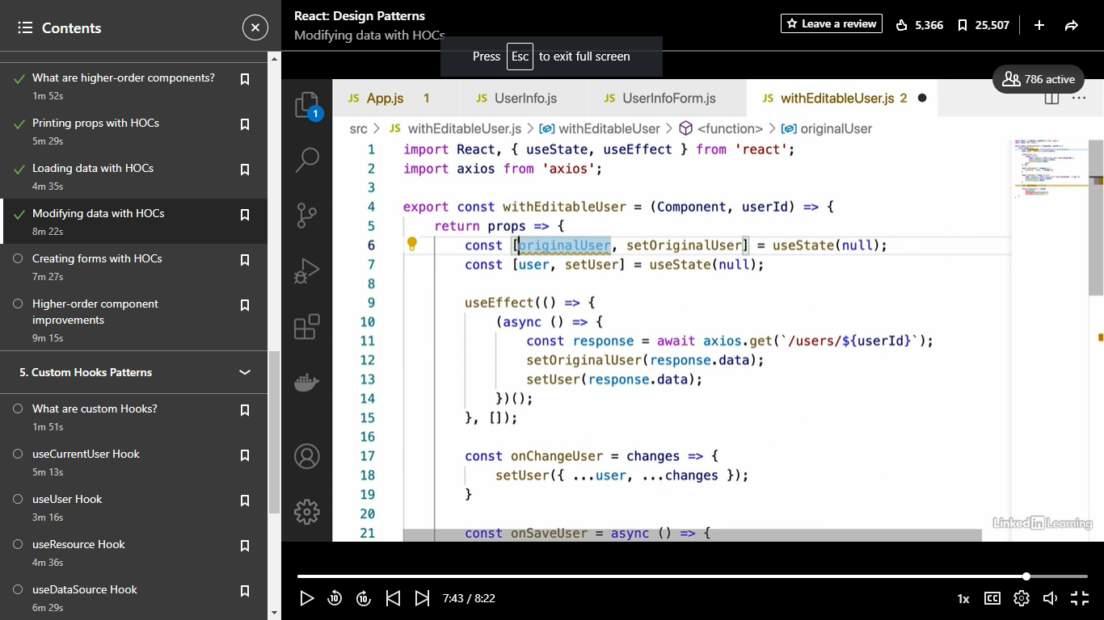

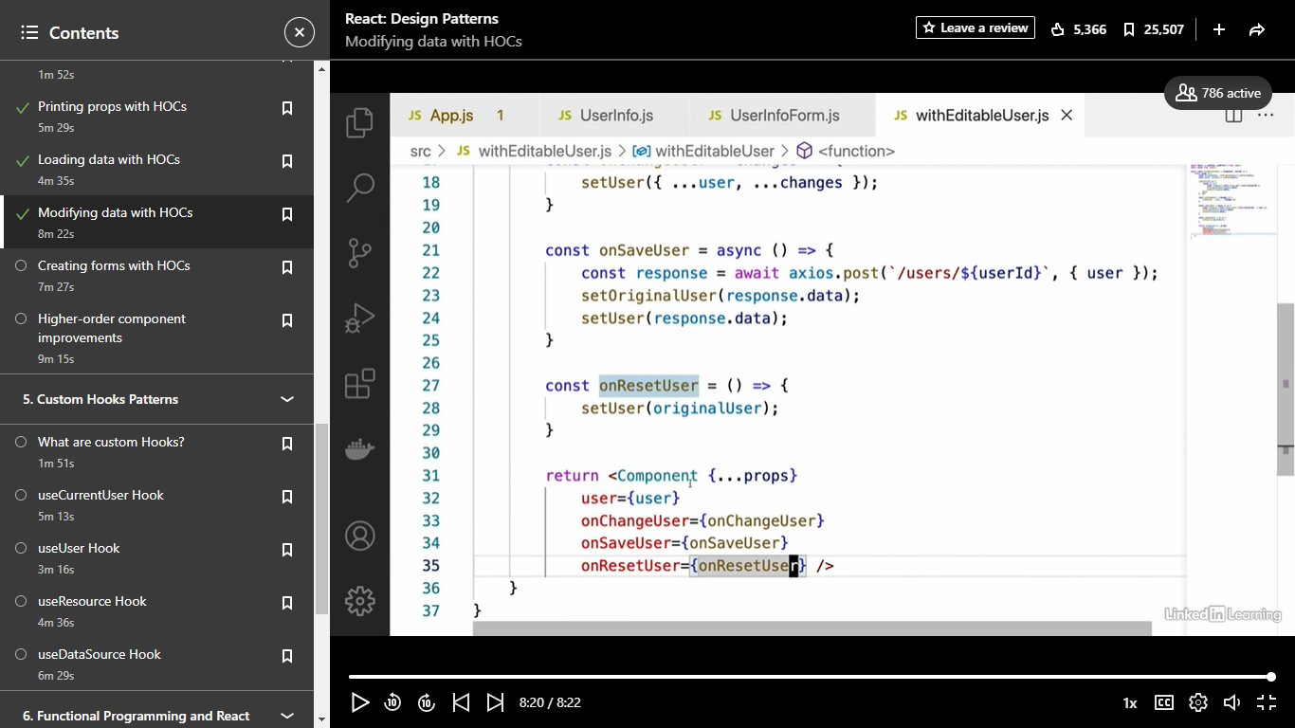

Forms

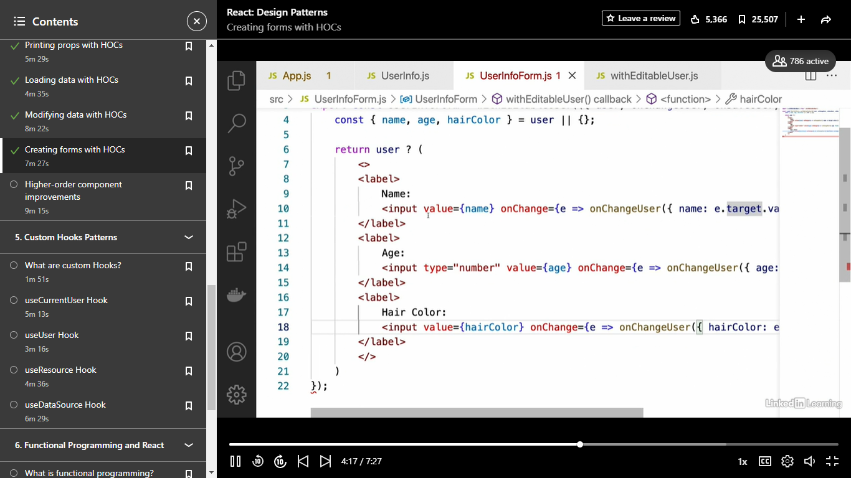

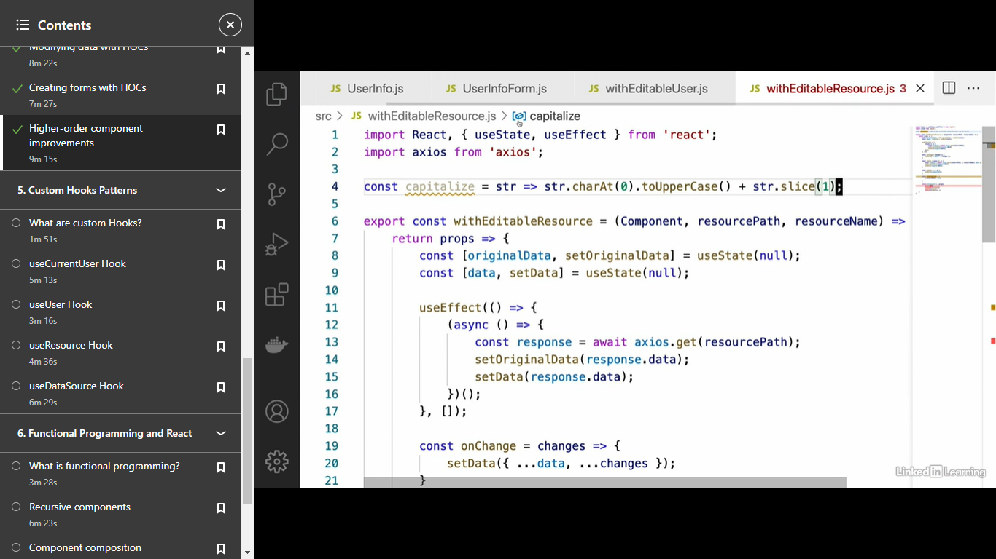

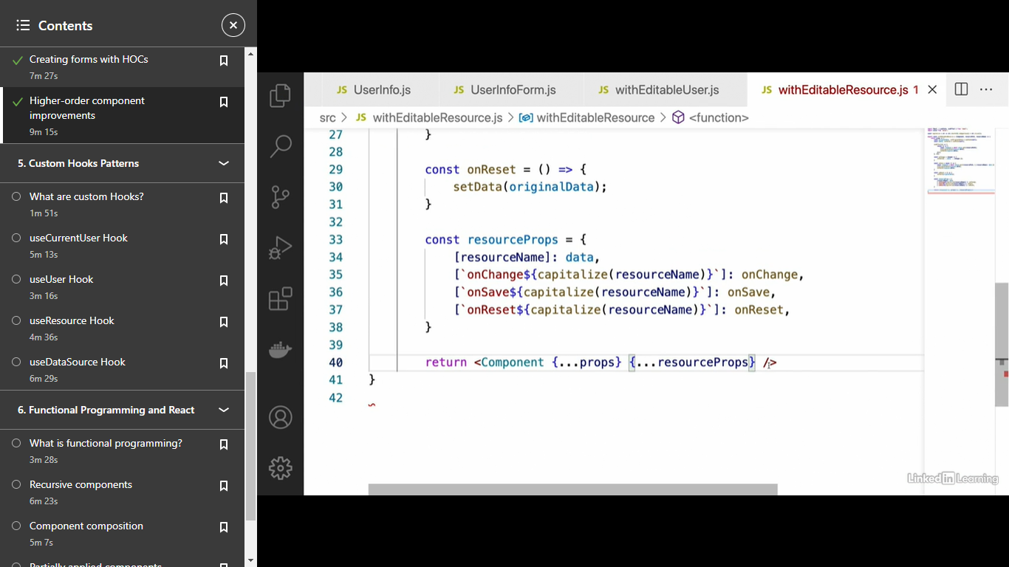

- [Instructor] All right, so now that we've seen how to create a withEditableUser higher order component, we're going to take this one step further and create a withEditableResource higher order component. This will be kind of similar to what we did earlier in the course when we created a container component that did the same kind of thing. So, here's what this is going to look like. We're going to start off by creating a new file for this higher order component which we'll call withEditableResource as I said. And we're going to start off by copying and pasting the withEditableUser higher order component. So we're just going to be making this a little bit more generic and reusable. So first of all, let's change the name of this higher order component to withEditableResource. And the next thing we're going to do is change the arguments a little bit. So it's still going to take the component as its first argument, the component that we're trying to wrap and then pass props to. But as it's second and third props, instead of taking a userId, since we're going to be working with resources instead of just users, we're going to be working with any kind of data, we're just going to specify the resource path, that is the path on the server, and we're going to specify the resourceName. This is again similar to what we did earlier with container components. So the next thing we're going to do is just kind of make a few name changes. We're going to change originalUser to originalData and change this as well since we're not just dealing with users anymore and we're going to change this to data and setData. Okay and now that we've made those changes, we're going to go through and change the logic inside the useEffect hook. So instead of having our user's endpoint hard-coded here, we're going to say axios.get resourcePath. That's going to be the server endpoint there. We're going to say setOriginalData response.data and setData response.data to reflect those name changes we made. And then what we're going to do is go through each of these three functions onChangeUser, onSaveUser, onResetUser and make those more generic as well. What I'm going to do specifically is change this to onChange, onSave and onReset. Okay and then we're going to have to make these name changes in here as well. So setData, data and changes, setOriginalData and setData. And this URL here is going to have to change to our resourcePath. So resourcePath and then instead of passing the prop named user, we're going to have to actually specify the resourceName that we passed as an argument up here. So the way we're going to do that is in square brackets, we'll say resourceName. And then after that, we'll say data. Okay? And finally we have onReset which we just have to change to setData and originalData like that. And now comes the kind of tricky part. What we need to do, obviously we want to allow ourselves to pass in on changeUser, onSaveUser onResetUser. We don't just want to shorten each of these to onChange, onSave and onReset. And the reason for this is because there may be situations where we want to use the same higher order component several times over again. Let's say that we were building a component that needed to use both user data and product data from the server. Basically what we would do is wrap that twice with withEditableResource, right? We'd say withEditableResource and then withEditableResource again and then we would wrap some component. We might say HomePage or some component like that. And the first resource would be, you know our products and the outer resource here might be our users, something like that right? So in that case, we would need the onChange, onSave, onReset to have names such as onChange user or onChange product. So the way we're going to do that is we're actually going to create a separate object here called resourceProps. And we're going to use what I would call a little bit of ninja JavaScript to make this happen. So specifically for the first prop, that prop is going to have the name equal to the resourceName argument that we passed into our higher order component up above. So in this older case, we just said user equals user. For this one, we have to say resourceName and specify that for that one, we want to pass through the data state. And then we're going to do the same things for onChange, onSave, onReset. The tricky part with these is that we have to actually add on onChangeUser, onSaveUser, onResetUser or whatever the resource name is to the end and we have to capitalize that. So the way that we're going to capitalize that string is by defining a capitalize function up at the very top of our component file. And this is going to be where the ninja JavaScript comes in. We're just going to say that this function takes a string and we're going to say string.characterAt(0).toUpperCase plus string.slice(1). Okay, basically all this does is it capitalizes the first letter of a string. Don't worry too much about the JavaScript details there if you're not super strong in that. So, now that we've done that, what we're going to do is specify the other prop names inside this resourceProps here. What we're going to do, we're going to use square brackets and say onChange. And then into this template string, we're going to insert the capitalize resourceName, so capitalize resourceName, and that's going to be our onChange function that we defined above. And then we're just going to do this exact same thing with onSave and onReset. Okay so onSave, onReset and we're going to change these as well. And that should really be all we need to do. The last thing we're going to do is just replace all of these user onChange, on Save, et cetera, and pass the new resourceProps that we've defined there to our component. So we're going to say resourceProps like that and that should be all we need to do. So let's see how this thing is going to work. Oops and I accidentally deleted a curly brace there. So the way this withEditableResource component is going to work is we're going to go into our userInfoForm component that we had from earlier. And instead of using withEditableUser, we're going to change this to withEditableResource. So let's say import withEditableResource, change this here to withEditableResource. Okay and the props that we're destructuring inside the component are going to be exactly the same Because we're going to pass in the resourceName and resourcePath which will be taken by our withEditableResource higher order component and converted into onChangeUser, onSaveUser, onResetUser and so on. So now we just need to change the final props that we're passing to this higher order component. First we need to pass in the path of the resource we want to load which is going to be /users/123 and then we just have to pass in the name of the resource which is going to be user. All right, so let's see if this thing works now. Make sure you have your frontend and backend both running and we'll head over to here and refresh. Sure enough we see that it correctly loaded the data for us. And if we try and change this now, we'll change a few of these properties here. Give John blue hair, click on Save Changes. And if we refresh now, we'll see that those changes were persistent on the server. And we can also see that reset works if we just make a few random changes to these things here. Click Reset, that will reset all of those things to what they were before. So as you can see, everything is working just like we had it with our original withEditableUser, except now we can change basically any kind of resource, be it products, users, articles, anything that we need to. So that's the real power of higher order components in React.

### Custom Hooks

- [Instructor] All right, the next React design pattern we're going to take a look at is the pattern of custom hooks. So, what are custom hooks? Well, custom hooks are basically when instead of just using the basic hooks that React provides us with, such as useState and useEffect, we actually combine these hooks into our own new hooks. So, what this might look like is, let's say we want our component to have access to products from the server. Well, we could either create the product state and actually load the products inside the component itself, or we could create our own custom useProducts hook that encapsulates this functionality. We're going to see how to do this very shortly, but this that you see here is what custom hooks will generally look something like. When we use custom hooks, right? Once we've created our custom useProducts hook, useUsers hook, whatever kind of resource or functionality we're trying to encapsulate in that hook, the way we use it in our component is usually like what you see here. We just say const products = and then our custom hook. And one thing to note is that custom hooks do have to start with the word use, okay? That's just something that React requires us to do and it has to do with the way that hooks work behind the scenes, but we won't get into that right now. So, custom hooks are used for pretty much the same thing that we've seen with higher-order components and container components. They're used to allow us to share complex behavior between several different components, right? Like what I said before, if we want to, say, load products from a server, instead of having to specify that same loading logic over and over again, we can put that logic into a custom hook and simply use the hook in each of our components.

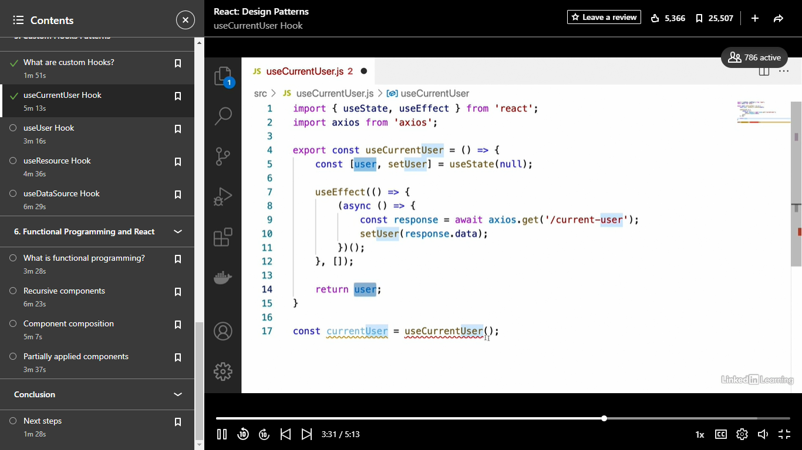

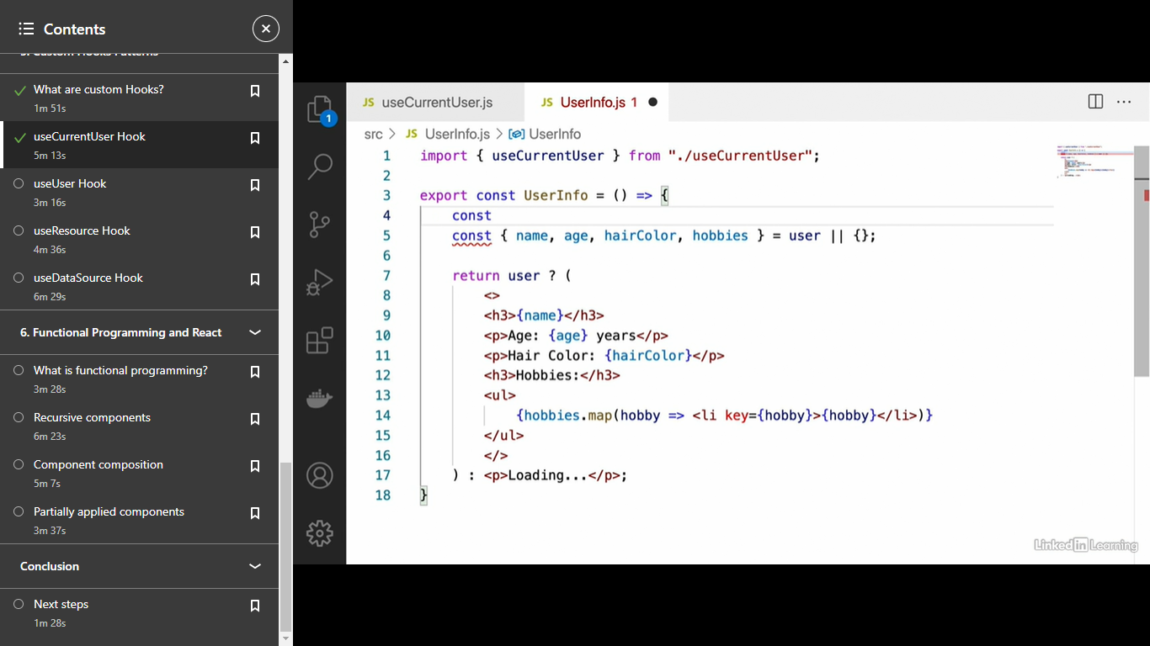

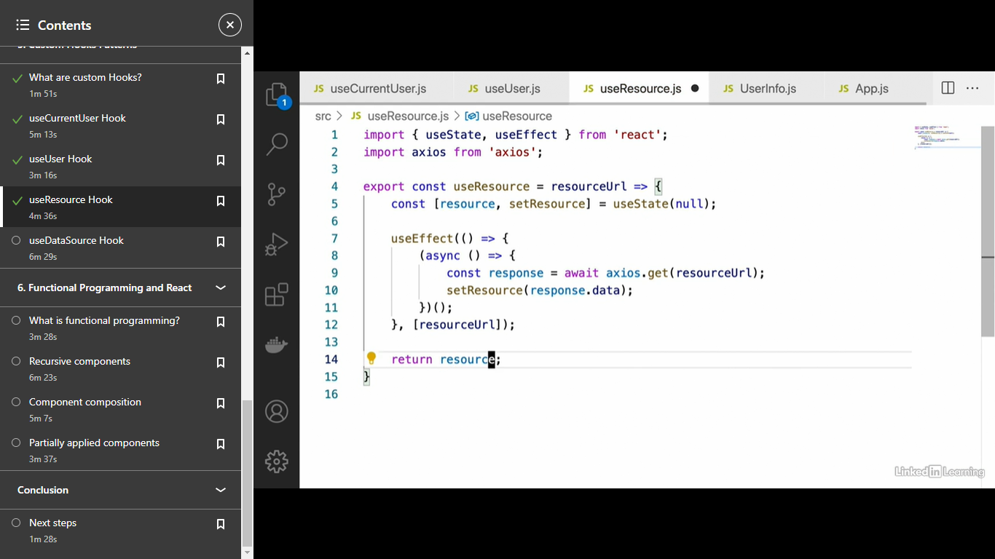

Use datasource

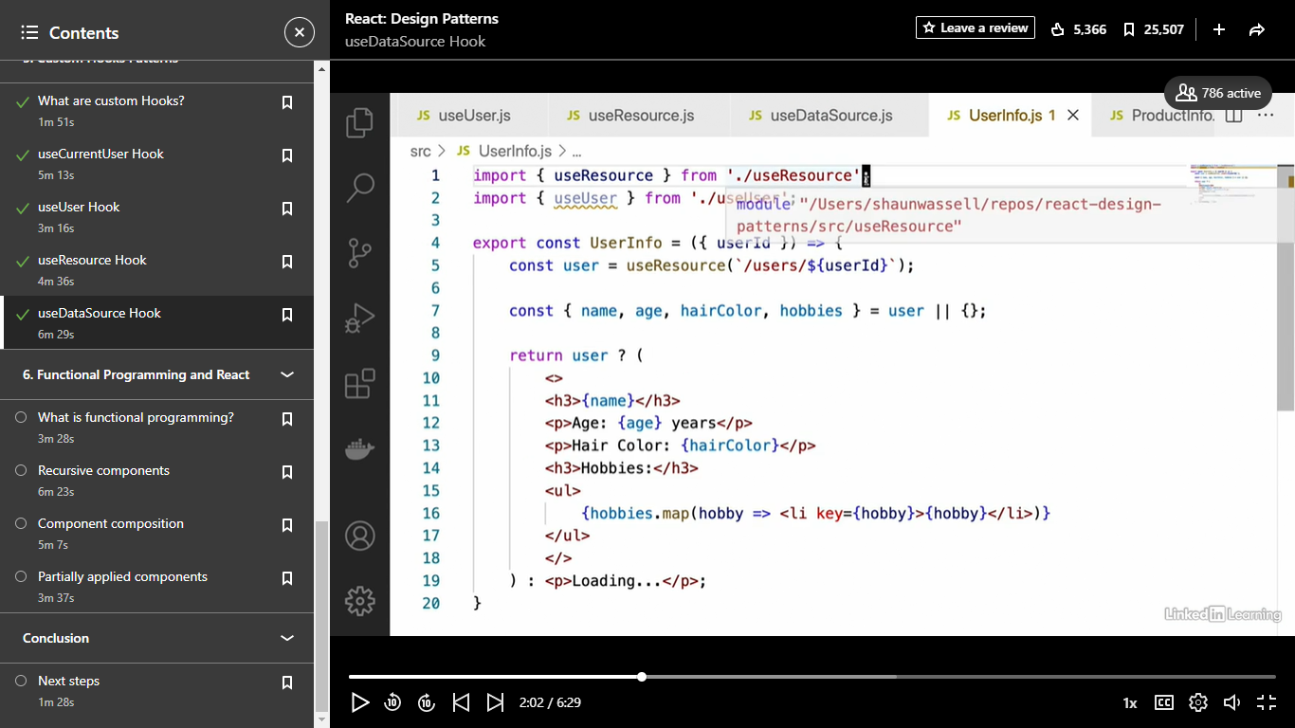

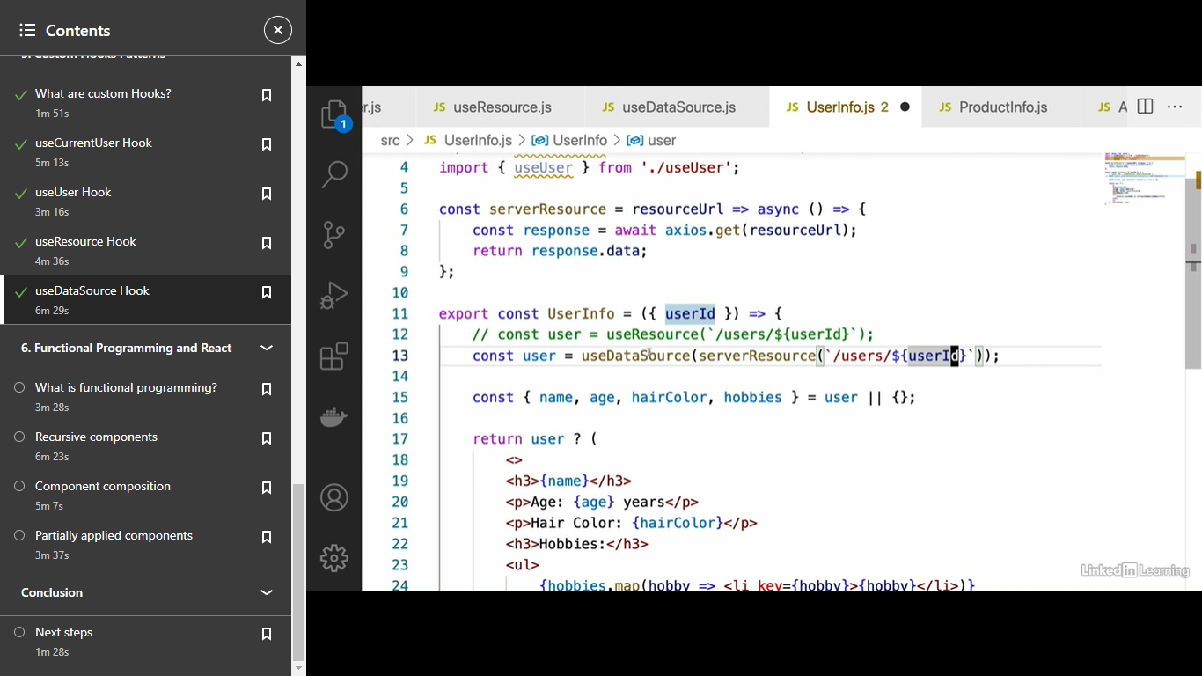

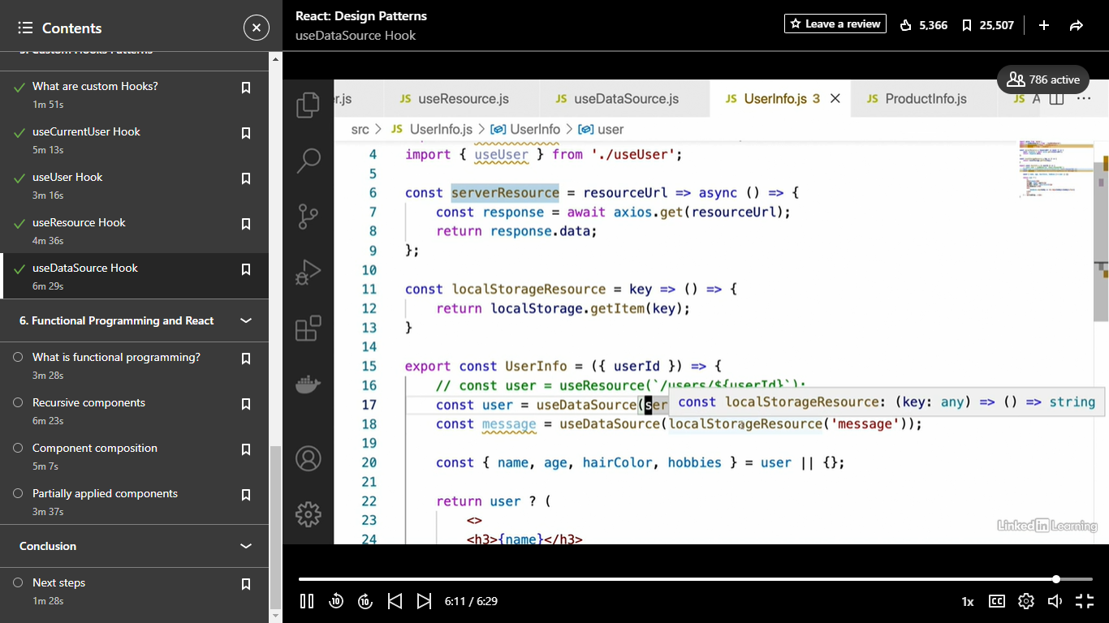

Functional Programmin

- [Instructor] Okay, so the final topic that we're going to talk about in this course is functional programming and how do we incorporate it into our React applications. Now I don't refer to functional programming as a design pattern, but functional programming itself does lead to some very interesting design patterns in React and that's what we're going to be taking a look at here. So first let's start off with a definition of functional programming. Now, functional programming is a very broad topic, and I do have some courses on that in the library. So if you want to go into more depth here, feel free to take a look at those. But the basic definition that I'm going to give you here is that functional programming is a way of organizing our code base such that we minimize mutation and state change in our applications, we keep our functions independent of external data, this is something called pure functions, and we also treat functions as first-class citizens. Now I realize that this may be kind of an opaque definition for those of you who aren't familiar with functional programming yet. So again, I highly recommend that if you want to get into this more deeply, go take a look at one of my functional programming courses in the library. So let's talk about some of the applications of functional programming in React. Some of the most common applications of functional programming in React are something called controlled components. All right, so controlled components, which we saw earlier in the course, basically the idea of those is that we can get the component into any state we want simply by passing in the right props. So the component isn't keeping track of its own state, and that's a pretty functional concept there. The next application of functional programming in React is function components. Now those of you who have worked with React for a long time are probably familiar with the fact that there are two ways of defining components in React, either as classes or as functions. And as it happens, the act of defining our components as functions is itself, a very functional way of writing code. Next up we have higher order components, which we've already seen in the course. Higher order components because they're functions that return other functions, which is an application of something called first-class functions. This is a great example, actually, of functional programming in React and some of the things that that allows us to do. All right, so we've seen these three pieces already. The next three pieces that I'm going to talk about are the ones that we'll be working on in this section. The first one is recursive components. Recursive components are basically components that use recursion in order to achieve a desired effect. These can be very cool. So I highly recommend that you stay for that video. Next up we have partially applied components. Partially applied components basically allow us to take more general components and by passing in only a subset of that components' props, create more specific versions of that component. Again, take a look at that a little later on. And finally we have component composition. Basically, this is when we take several different components and are able to combine them into one component to achieve a desired effect. And again, we'll look at that later. So those are some of the main examples of functional programming in React. Each of these, as we've seen, forms its own react design patterns. So let's take a look at these last three that we haven't seen yet.

Recursive Component

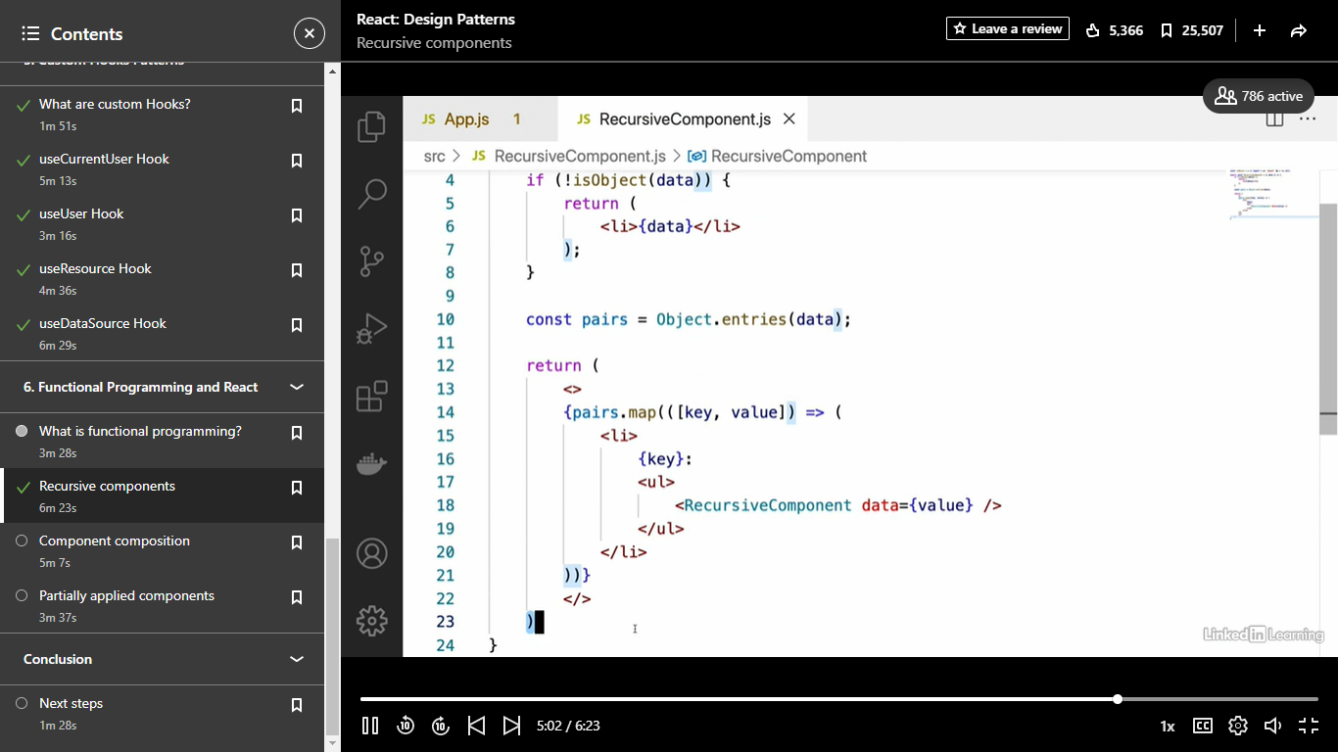

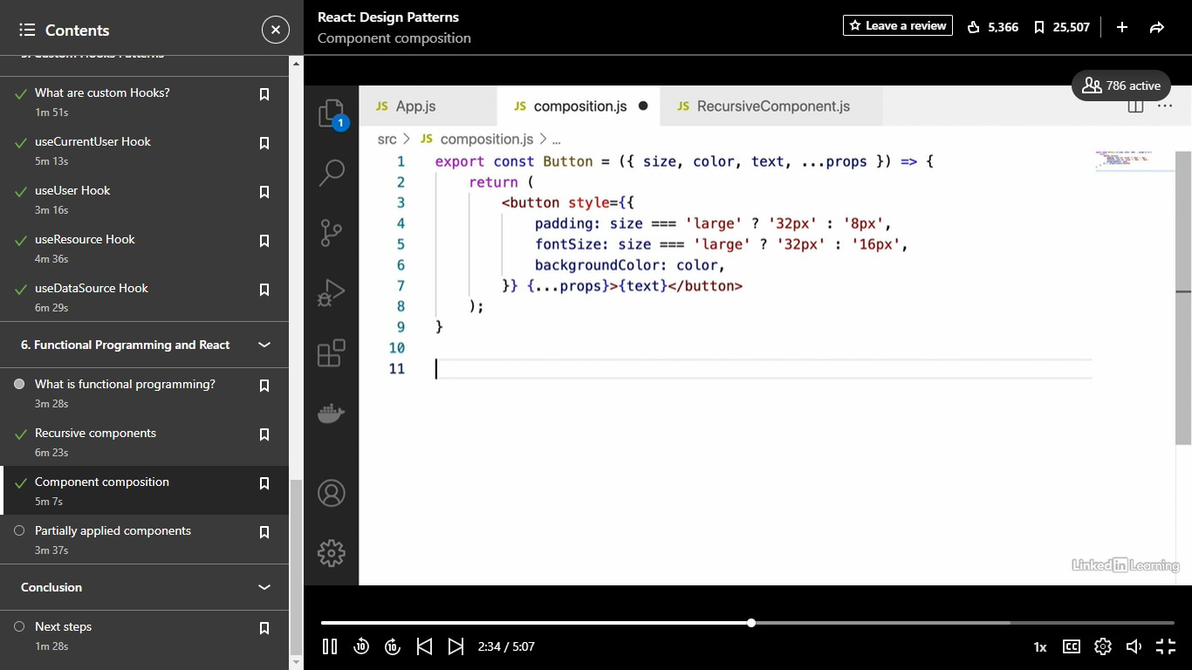

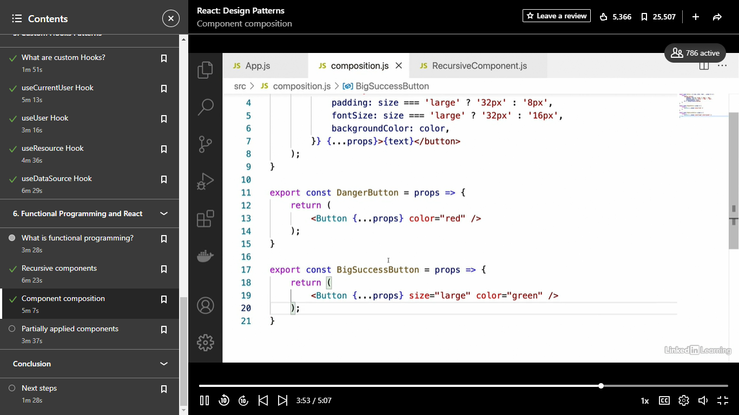

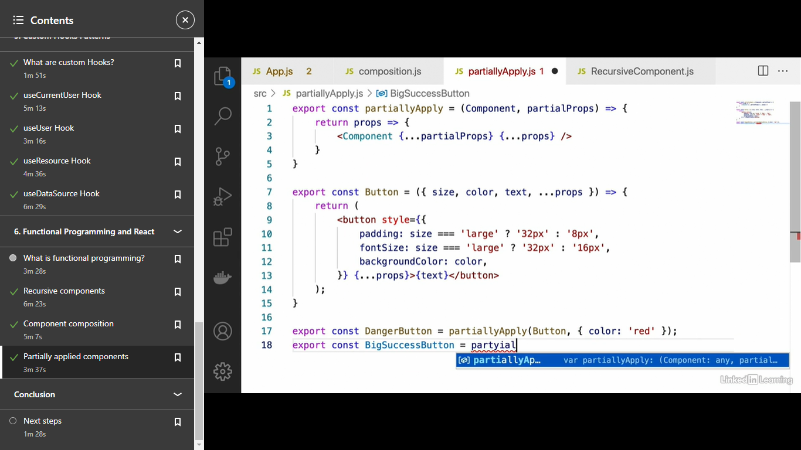

- All right, well we've come quite a long way in this course, and learnt a lot of different react design patterns. Just as a brief recap of what we've learned. We learned about layout components and how to use them to organize the components we create on the screen. We learned about container components, which allow our components to share different functionality between them through means of a parent component. We learned about controlled and uncontrolled components and some of the differences between those and why we prefer controlled generally. We also covered higher-order components and some of the things that you could do with those, right? How to use them to add functionality to an existing component. And we also learned about custom hooks. And finally we closed out with some functional design patterns such as recursive components. So now that the course is coming to an end, you're probably wondering where to go next. Well, the main next step that I would recommend for you is to try incorporating these concepts into your own applications. This will both allow you to get a better handle on the concepts we covered, and it will give you a lot of practice so that you can eventually memorize these design patterns and have them become second nature to you. And just as one last thing, if you want to connect with me on LinkedIn, feel free to do so. I'm on LinkedIn quite often, and would love to hear any questions or comments from you directly. So just feel free to send me a connection request there. Well, thank you so much for watching this course, I hope you found it valuable, and I hope to see you in another course.